ASSIGNMENT-7.2

Name : Sharanya Thanugula

Hall ticket No: 2403A51401

Batch:16

Task 1:

Code:

Explanation:

Task 2:

Code:

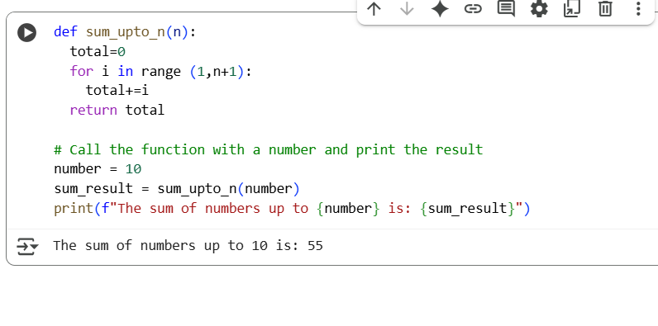

Explanation:

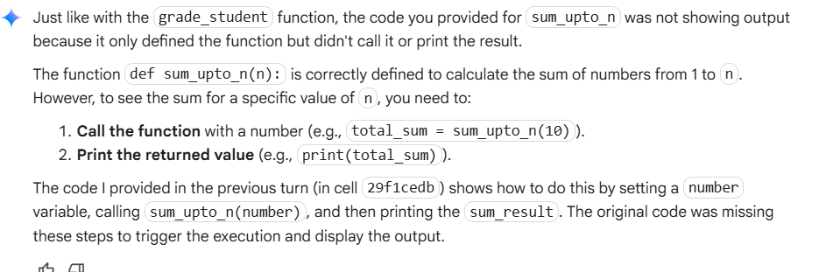

Task 3:

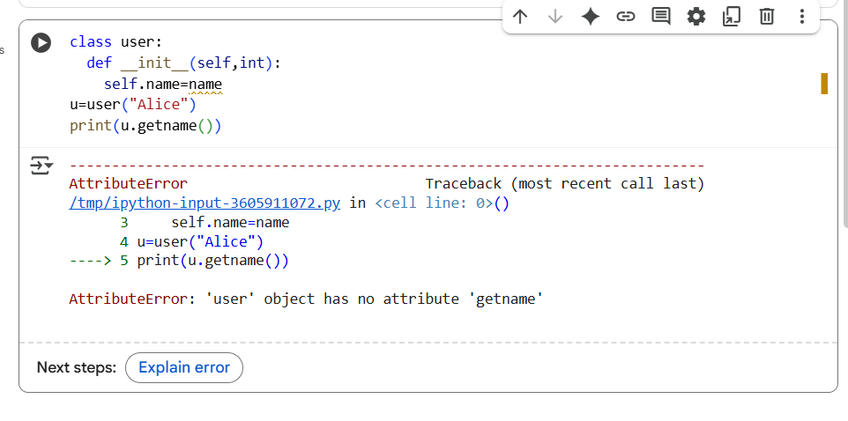

Code:

Explanation:

Task 4:

Code:

Explanation:

Task 5:

Code:

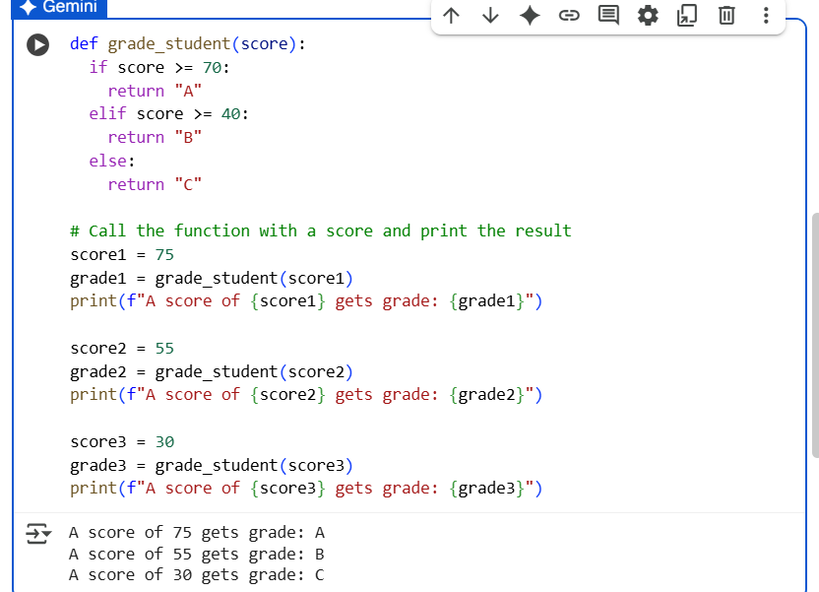

Explanation:

